Meeting 22
Course / Class #: CECS 4800

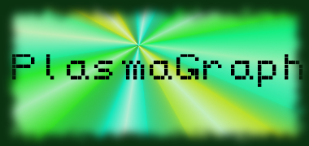
Date: 13 March 2014
Project Name: PlasmaGraph

Has been done:
- Meeting with client. Discussed changes to product.
- Additional changes to GUI-related classes. (Created data log view)
- Added Matlab reading functionality to end product.
What will be done:
1) Bugs fixing. (Outliers, display messages, some interpolation algorithms not displaying data)
2) Changes to GUI (two floating windows instead of one)
3) Include MATLAB file specifications in SRS
4) File size limit testing. (csv, mat)

Materials Used: 2x Computers, Internet connections, Microsoft Visio / Dia (Diagramming Tools), Eclipse / NetBeans IDE (Programming Tools).

Group Members: ________________________________
Gerardo A. Navas

________________________________
Daniel Quintini
Professor:

________________________________
Prof. Luis A. Ortiz

